Practical 5

Aim: Matrix Multiplication Application using Python and MapReduce

Check the current working directory and changing the current working directory to the folder matrix
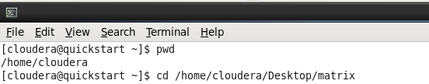

Step 1: Create 2 matrix text files with shape 2x3 and 3x2 in a folder(Here we name the folder as matrix)
Matrix 1:
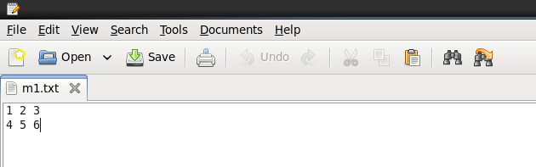

Matrix 2:
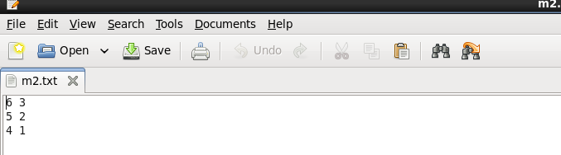

Step 2: Now create a mapper function in python and save it in the same folder as the matrix text files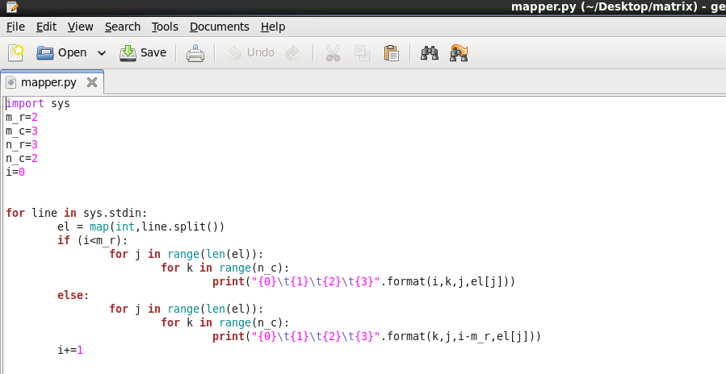

Step 3: Create a reducer function in python and save it in the same matrix folder
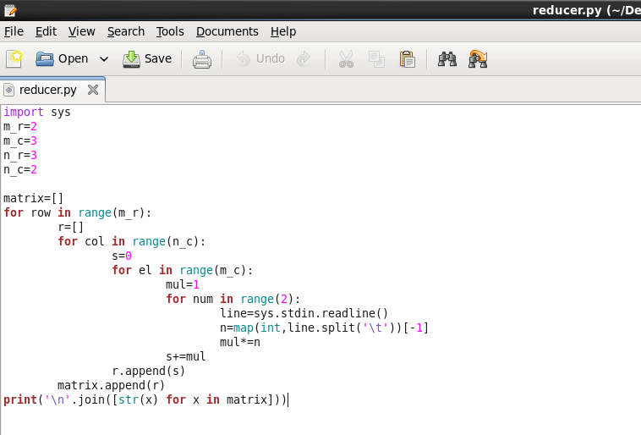

Step 4: Checking the output of the mapper.py function
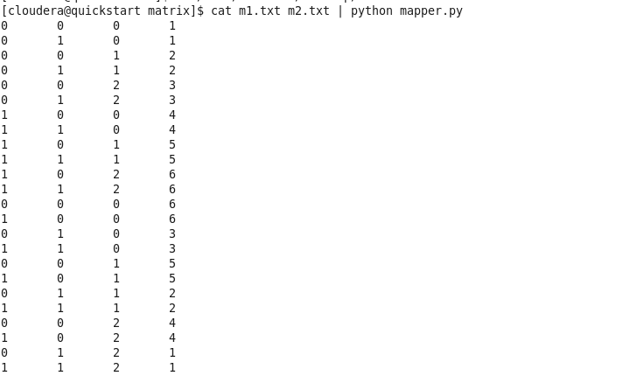

Step 5: On running the mapper and reducer function together along with the 2 matrix we get

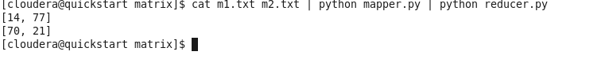
Conclusion:
[14,77]
[70,21]
This is the following output of matrix multiplication

